One big asset for you to review and use with the
participants at the place of your choosing

A. Thoughts to remember
1. You will discover that many Christians do not know
how to read the Bible, interpret it, much less apply
it.
2. One part of what I have tried to do in the books that
I have written, is to demonstrate how scripture
should be read, interpreted and applied. Thus, the
books are full of long passages of scripture.
3. I have termed the discipline of spending intense time
in Scripture beyond their relational and devotional
time with God, the discipline of hermeneutics. Don't
let that word confound you. It is all really very
simple. It is not the result of heavy theological
study, nor years of seminary study.
4. The discipline of hermeneutics is based upon three
easy actions:
a. Observation: what is the passage saying?
b. Interpretation: what does the passage mean?
c. Application: how can the meaning of the
passage be applied to my life?
5. Many more things can be applied to the
process like commentaries, language studies,
comparative passages in other places of the Bible,
and of course, preparing an outline from which to
teach the passage. But, at this point, I am just
trying to get everyone comfortable with spending
deep time with God in His word. Even people
responsible to teach others need to begin
somewhere. And too often they begin with ways to
preach rather than what they are preaching. The
content of the Bible will stand on its on, even if just
read out loud. So we want to make sure that what
we say only makes the inspired words of scripture
clear…..not clearer, simply clear!
6. So, I advocate that all who can spend at least one
day a week lingering longer over a passage of
scripture and looking beyond devotional time with
God.
a. Spend six months or more on one book of the
Bible
b. Read it over and over again until you are
comfortable that you understand what it actually
says. Several weeks of this are not too much
c. Along the way, make notes to yourself about
what you see, questions you have, words that
need more study, and other passages that come
to your mind that might help explain the
passages in this book.
d. Try your hand at outlining the book as you see
the themes of the passages fall together.
e. If you want, search word meanings in the many
other sources available online. Try a few
commentaries if you want.
f. Try writing out a few applications to the major
sections to the outline that you have created.
7. Do this over the long haul of your life and you will be
surprised how much more comfortable you are
with God in His word, how you become capable at
distinguishing good from evil, and how you are
prepared to allow the Spirit to use His word to give
you daily direction in righteousness decisions.

B. The process for understanding the mind and
will of God Scripture

The importance of getting it right:

1. Because that is our task
I Timothy 4

2. Because only the word can correct and heal
2 Timothy 3:10-16
Hebrews 4:12-16

3. Because you are a “first fruits of what God wants for His people
Hebrews 13:7
I Timothy 6:11-14

4. Because we will be held accountable for how well we represented the mind
and the heart of God
Hebrews 13:17

Blaise Pascal, The mind on fire
So too our faith is divine both in the Gospel, in the apostles, and tradition, but it can be made ridiculous by those who mishandle it. Pg. 179

The steps to discovering and detailing what it being said:

- What kind of a passage are we dealing with
  - History
  - Poetry
  - Future things, etc

- Who is being addressed
  - Or, to put it another way, what generation of revelation is being addressed, therefore, how far do the statements go in being applied to every generation
  - Is there a principle being stated that would transcend time

- What is being said
  - Who is writing
  - Who are the immediate hearers
  - What is a possible outline of the content
  - What are the themes being addressed

The steps to interpreting what is being said:

- Is there a relationship to similar themes other places in Scripture
  - Where
  - Is it similar or exact
  - Does the related passage change or enhance our understanding of the present passage

- Are there words, concepts, or doctrinal relationships that need clarification
  - Will a review of some of the words in Greek change or enhance our understanding
  - Will a review of a few commentaries highlight resolutions in a difficult passage
  - Will a review of study resources highlight resolutions or at least understanding of key, potentially polarizing doctrinal concepts
  - Take written note on cards or at the bottom of the sheets you are working on, of discoveries that need to be taken into mind as you move on to form interpretations and applications

- With a “detailing” outline in hand, go on to add interpretative thoughts to each of the major themes discovered as sub-points to the outline

- Once a more mature outline is complete, go on to compare the interpretative thoughts with what was discovered in a review of the key words, concepts and doctrinal relationships study

- Make note of the adjustments of in the body of the outline that you have been working with, below each appropriate theme.

The steps to drawing conclusions and making application to our lives:

- Identify each of the major themes in the passage in the outline, and below each, begin to note applications of the theme to personal life, married life, family life, vocational life, and the life of the local body.
- Note below each of the themes, what you personally learning from each of the themes, and some commitments that the Spirit is leading you to consider, and make.
- With these two actions in hand, go back again to the discovery and detailing section and check that your applications are in concert with the kind of material and generation of revelation you are dealing with.
- With all of this in hand, go back again to the interpreting section and check that your conclusions and applications are in concert with what you discovered about the same or similar themes other places in Scripture.

C. Allowing the Holy Spirit to use your time with God the Father in His word to give you daily direction in making decisions that build His life in you, and declare in your actions that you belong to Him.

Find below an design that shows how I view the work of the Holy Spirit in giving us daily guidance in our decision making that results in matured righteousness that can be seen by others, and give glory to God.

In order for this to happen, we must give ourselves to daily time in God’s word, filling our minds. The Bible is the only language that the Holy Spirit speaks. When we don't spend time getting to know God’s word, contemplating it meaning, and committing ourselves to obey it, what does the Spirit have to work with? He has nothing except a religious confession. And, religious confessions will not in and of themselves bring the transformation that God has designed, the resurrection of Jesus Christ anticipates, and the residency in us of the Holy Spirit makes possible.

What do the major pieces of the design on the next page mean?

1. There is only one foundation for living for the follower of Jesus: the word of God. Unapologetically, we build our lives on it. It is our primary source of faith, life and witness.

2. The boundaries of our lives are also the word of God. Anything outside of its commandments for our lives is always NO.

3. Inside of the boundaries there is great freedom.
a. I fill my mind with the word of God
b. The Spirit uses those words to not only give me joy and
encouragement but also correction and instruction.
c. As I live my daily life tethered to the foundation of the Word of
God and listening to the Spirit, every occasion through out the
day presents me with at least three alternatives: yes, maybe or
what I call a sanctified no.
YES, means the Spirit is saying yes, move ahead.
MAYBE, means that there is nothing sinful in the action or
decision, but the Spirit is telling me to wait.
NO, means the Spirit again is saying that there is nothing sinful
in the action or decision, but His will for me is NO. That's
way I call it a sanctified no.

﻿
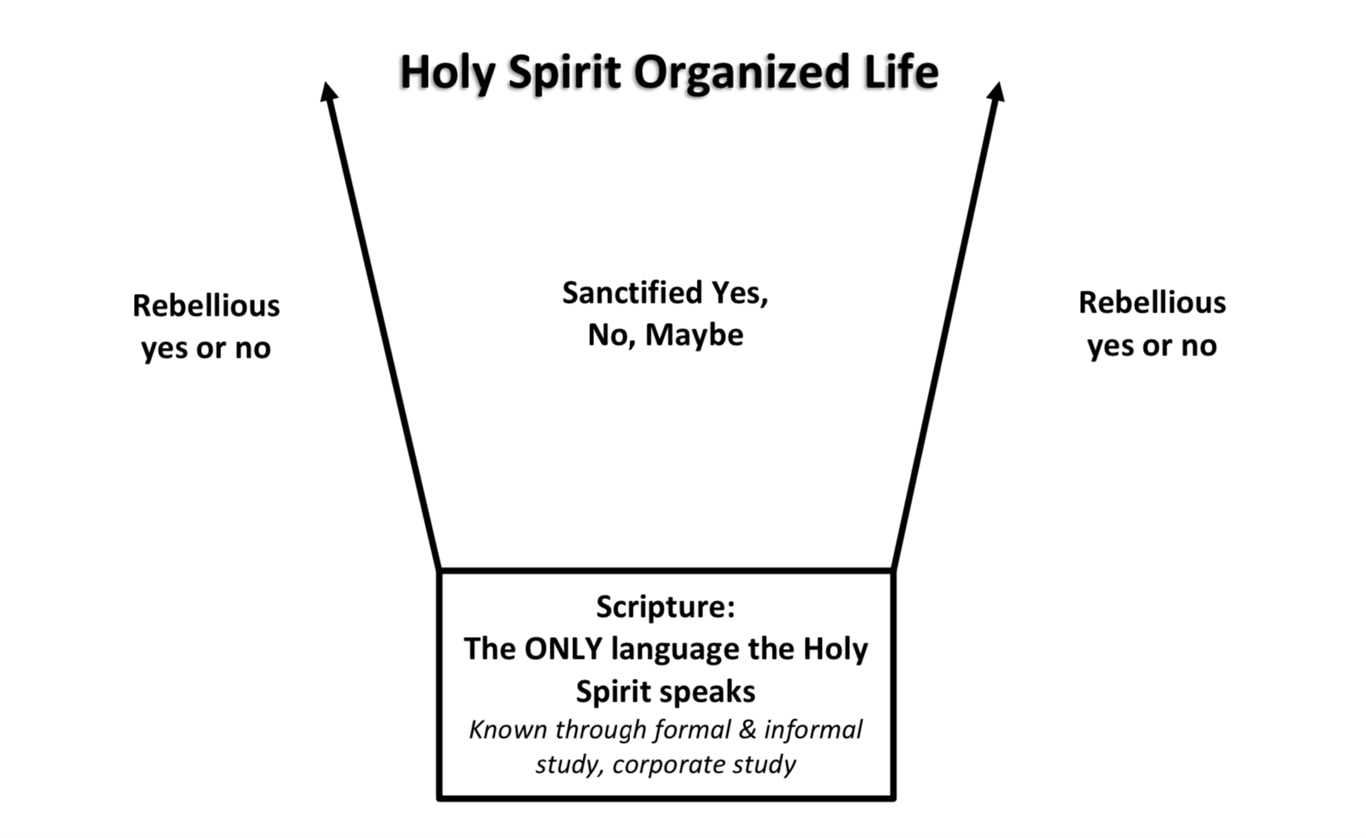

All material in this package is
Copyright by,
Dwight Smith, March 30, 2020

